Car Acrobatic Team: The Interview
Nate Heiss
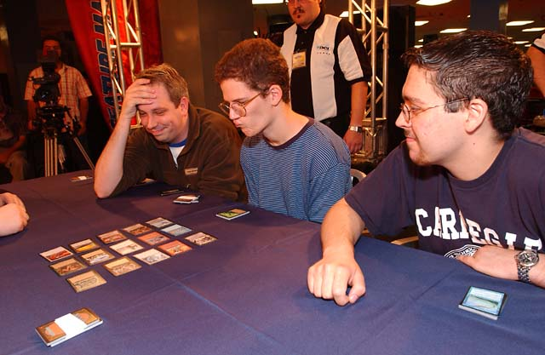
Forsythe, Cuneo and Johnson
Aaron Forsythe, Andrew Johnson, and Andrew Cuneo. These three Magic players of Team CMU have performed an astounding feat matched by no other team in the history of Magic. They teamed up on a chance to go to a qualifier one fateful day over a year ago and created Car Acrobatic Team... now, two Team Pro Tours and a whole lot of money later, Car Acrobatic Team is the only team to make two Top 4s at the Team Pro Tour. Oh yeah, and they were consecutive.
Being privileged enough to be on Team CMU with these guys, I was able to get an exclusive interview out of Aaron Forsythe and Andy Johnson about their experience at this year's Team Pro Tour. This Pro Tour was very important to these guys... Aaron was in danger of falling into the unqualified nether-regions of a pro player, and Johnson faced the same fate if they could not repeat the amazing performance of the year before.
The first part of the year was rocky for all the members of the team, with no member doing particularly well at any individual pro event. However, for some reason, when these three guys team up, something clicks and nothing can hold them back.
Now for a look into the minds of the most successful team on the Pro Tour today, Car Acrobatic Team of Team CMU:
Sideboard: Everyone probably has the same initial thought when they hear about you guys... why are you called the Car Acrobatic Team?
Andy Johnson: It's a reference to the bad guys in Speed Racer. Aaron thought it up, and it was better than Cuneo's vote for Myth Science Arkestra.
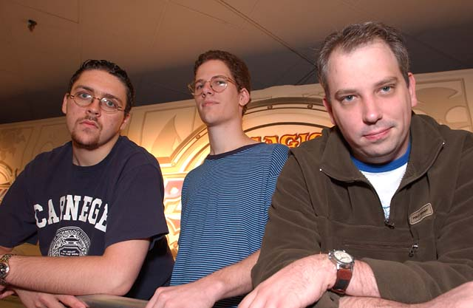
Aaron Forsythe: I wanted a team name that was a pop culture reference with the word "team" in it. Other than "The A-Team" this was all I could think of. The C.A.T. are the villains from old Speed Racer cartoons. I never really thought we'd need the name this long - I made it up for a PTQ last year.
SB: Funny, the A-Team seems rather appropriate, considering all of your names start with 'A'. Considering how well you did the year before, how much did you practice for this year's Team NY?
AJ: We did many drafts and sealed decks at the O', but Worlds interfered a lot, so not as much as last year.
SB: Well, it looks like the Worlds testing paid off for Turian, so it was not wasted! What do you think Aaron?
AF: We certainly didn't test as much as last year, but we at least had a framework from the Masters in Tokyo, and some good ideas from the top teams in Columbus. So we weren't working in a vacuum either.
SB: How did you guys feel when going into the tournament?
AJ: Like we needed to do really well to keep going. I didn't feel very confident until we sat down for our first round. Then all my doubts were gone.
AF: Hesitant, as usual. I rarely feel like I'm going to do great. I guess that's a problem with me.
SB: It seems that everyone has those same human nerves. It just goes to show that being a little worried does not mean that all is lost! What was your general strategy for sealed deck?
AF: Split all the gold and multicolored cards up and see which combinations cry out to be used. Apocalypse makes the sealed deck part hard, because you only get a handful of opposite-colored cards, but they're usually pretty broken.
SB: What was your general strategy for draft?
AF: R-W-b or R-B-x in seat A (me), 5cG for seat B (Cuneo), and U-B-x for Andy in C.
SB: Many teams used outside collaboration to keep up with all the current strategies. Did you discuss many strategies with teammates and/or other Pros?
AJ: Just collaborating with Mike [Turian] and other guys. We tried a lot of stuff.
AF: Mike Turian was quite helpful as always, and he had contact with Scott Johns and Zvi who were putting in a lot of work. Our initial ideas came from Matt Vienneau and Mike Pustilnik more or less from GP-Columbus.
SB: The networking that pro's do is almost as interesting as the tournaments themselves. Speaking of the tournament, what was your most exciting play of the weekend?
AJ: Attacking with everyone against Kai in the semis when he could have opted to trade his Disciple for my Familiar.
AF: Alpha-striking Peer Kroger and then killing him with Zap off a sac-land. It was a very complex board.
SB: I guess the Car Acrobatic Team loves to attack with their guys. It is not an uncommon trait among CMU members. What do you think about your teammates?
AJ: They are great. Cuneo is very perceptive and Forsythe is a force.
AF: Cuneo is a great thinker and can't be phased by any other players. Andy J was screwing up in practice a lot, but he sure put on his game face at the PT. It's hard not to like your teammates after back-to-back Top 4s.
SB: Well said! I would certainly have no complaints! You guys kind of came out of the blue... what advice would you give to an aspiring team?
AJ: Practice with the best people you can find and get good at sealed deck.
AF: Seeing that the two most successful teams are probably us and Your Move Games, you should play with people you can practice with. That way you're always on the same page. You have to trust your teammates' opinions, and if you've been playing with them for a while, you'll understand their decision-making processes.
SB: Those two points have proved themselves true many times in the three year history of the Team Pro Tour; geography and player strength. Who do you think was the strongest link on the team?
AJ: Cuneo was the strongest drafter. Aaron brought cohesion to the team. I happen to think I am the best player, but I am sure my team would argue.
AF: Strongest? Andy Johnson probably. We hadn't really practiced drafting U-B in his seat, just U-W-r. But he made the switch smoothly, and I think he won more matches than Cuneo or I did.
SB: While this question may seem out of the blue, everyone always wants to know... what are your favorite cards and why?
AJ: Probe in IBC, because it's a freaking beating. Counterspell has always been my favorite card, as I am a blue mage at heart.
AF: Playing black-red in this format has endeared me to Blazing Specter.
He's not fair.
SB: I agree... Blazing Specter certainly isn't fair. Everyone knows that I am personally endeared to Manakin, but I think I will probably learn to love Millikin as well. How about your favorite formats... what are they?
AJ: Sealed deck, and sets.
AF: Any Limited formats. The internet has made Constructed into an arms race. Limited is still more a battle of wits.
SB: Indeed. Constructed is almost as much about mind games as it is strategy. Now here is something that I know may be a hard question, so take your time: What is the biggest difference between casual play and the Pro Tour?
AJ: The attitudes of the players.
AF: The Pro Tour elevates Magic into a worldwide pursuit. I've gotten to travel to many different countries and meet all types of people. I guess casual play is more of a hometown, same bunch of people type thing.
SB: Well said... for those of you who are aspiring to make it big: take note! Well that is all, thank you guys for the interviews, I am sure that the readers of the Sideboard will greatly appreciate it.

